Paper for ISMAR10 symposium. Topic No: 1

Implementing Incentivized Managed Aquifer Recharge on a Basin Scale
David R. Tuthill, Jr.¹ and Ronald D. Carlson ^{2,}*
¹ Recharge Development Corporation, PO Box 8, 144 S. Main St., Aberdeen, ID 83210-0008, USA. dave@idahowaterengineering.com
² Recharge Development Corporation, PO Box 8, 144 S. Main St., Aberdeen, ID 83210-0008, USA. theARUsolution@outlook.com
* Correspondence: dave@idahowaterengineering.com; Tel.: +01-208-870-0345
Academic Editor: Dr. Jose Antonio De La Orden
Received: date; Accepted: date; Published: date

Abstract: Managed Aquifer Recharge (MAR) may be defined as processes designed to move water from land surface to aquifer storage. MAR has been conducted in various locations throughout the world since ancient times. But virtually all of these efforts have been undertaken by or through a governmental entity (state or municipal), or by a private entity at a local scale involving one or just a few wells. Recharge Development Corporation (RDC) incentivizes entities to be involved in MAR through a patent-pending approach which includes eight elements that are assembled to create a unique Incentivized Managed Aquifer Recharge (IMAR) process. The paper discusses owned Aquifer Recharge Units (ARUs), municipal applications, groundwater district applications, tribal opportunities, and costs. The existing implementation in the Eastern Snake Plain Aquifer in Idaho is described. Criteria for other eligible basins are listed. The result is a case for application of these concepts in other basins throughout the western United States and internationally.
Keywords: Managed Aquifer Recharge (MAR), Recharge Development Corporation (RDC), Incentivized Managed Aquifer Recharge (IMAR), Aquifer Recharge Unit (ARU).

1.0 Introduction
Water users are challenged by less reliable water supplies as demands increase for water in arid and semi-arid locations. Climate change is resulting in lower annual precipitation or earlier runoff caused by the earlier melt-out of snowpack storage. High costs for constructing surface water storage and the associated environmental challenges incentivize inclusion of managed aquifer recharge (MAR) as a tool to enhance management options.
MAR has been a topic of significant discussion in The Water Report [1-6], a trade journal in the Western United States. No fewer than 34 issues have contained articles that incorporate this concept. These articles provide a broad survey of concepts and successful implementations of MAR. However, before the Research Development Corporation (RDC) concept, none of the articles has set out an incentivized mechanism for encouraging recharge to enhance usable water supplies in a basin. The recognition that such a mechanism is needed resulted in the creation of RDC, and three years ago led RDC to file a patent application for incentivizing local individuals and entities to become invested in basin water management.
RDC’s contribution to water management is to incentivize MAR by making recoverable MAR fungible and usable at the discretion of the Aquifer Recharge Unit (ARU) owner. An ARU is defined as one acre-foot (1,233 cubic meters) of water storage space in an aquifer. Incentives are intended to motivate all sectors which have built the water infrastructure in a nation to implement true conjunctive management in a hydrologically eligible basin. As clarified below this process not only results in incentivized aquifer storage but also enables the delivery of water for domestic, commercial, industrial, municipal and agricultural uses.
This paper provides an overview of a unique Incentivized Managed Aquifer Recharge (IMAR) process. From its genesis, a group of Idaho water users, lawyers, engineers and technical experts developed the operational concepts and legal approach for a defensible and robust IMAR program. The paper discusses ARUs, and the municipal applications, groundwater district applications, tribal opportunities, and costs. The existing implementation in the Eastern Snake Plain Aquifer in Idaho is described. Criteria for other eligible basins are identified. The result is a case for application of these concepts as the vehicle for not only incentivizing MAR, but also for implementing conjunctive water management in other basins throughout the western United States and internationally.

2.0 Conceptual Design
Eight fundamental concepts comprise the RDC Conceptual Design, as follows. The example aquifer in this paper is the Upper Snake River Basin Aquifer shown in Figure 1 below.

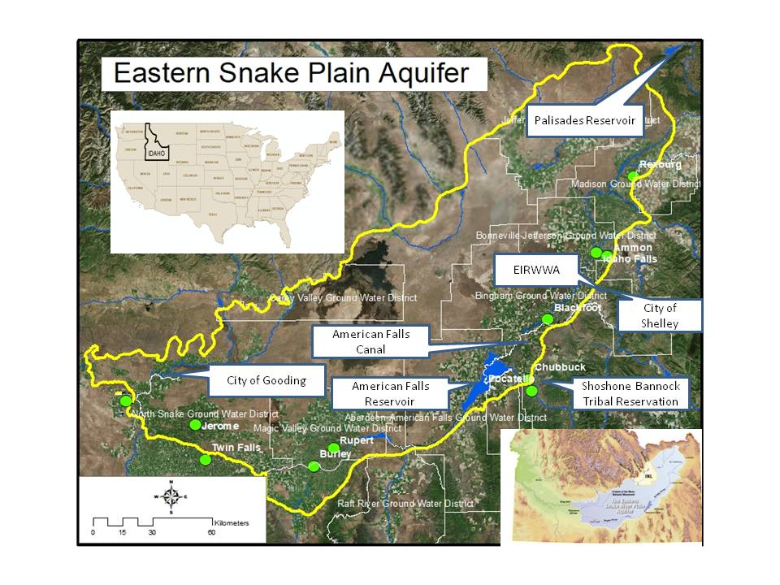
Figure 1. Eastern Snake Plain Aquifer

Concept 1. Incentivize private ownership of Aquifer Recharge Units (ARUs). The first concept of the RDC approach is that a water user can acquire title to virtual space in the aquifer via an ARU. Many water users are already familiar with contracting for space with the U.S. Bureau of Reclamation in a federally constructed reservoir. The reservoir space holders paid for the development of storage space which they acquire through contract. Space ownership guarantees a “bucket” to put water in but not the water to fill it. Some upper Snake reservoirs, like Jackson (upstream from the area of the Eastern Snake Plain Aquifer) and American Falls Reservoirs (see Figure 1) in the western United States have the earliest priority storage water rights, and space in these reservoirs is filled virtually every year. Reservoirs like Palisades Reservoir that fills under later priority water rights may not fill every year. Because storage space-holders rights must be balanced against flood control obligations, these reservoirs can be expected to have less than a 100 percent allocation 40 percent of the time. Similarly, an ARU holder in the Eastern Snake Plain Aquifer in southeastern Idaho holds a certificate representing their ownership interest in ARUs. As stated above, one ARU is equivalent to one acre-foot (1,233 cubic meters) of space. On the eastern Snake River Plain, an ARU can be filled annually by authorized MAR. Under current procedures, the ground water (Class G) ARU holder is offered water to fill the space at a cost based on the associated annual MAR costs. The owner can decide whether or not to fill his ARUs. Costs are discussed below. The Eastern Snake Plain Aquifer in known to have a storage capacity in excess of 500 million acre-feet (62 million hectare meters). Through defining an ARU as virtual containment in the aquifer, RDC has made available the equivalent of damming a natural lake to gain ownership of the storage space created.
Concept 2. Allocate MAR to owned ARUs. In Snake River Water District 1 (the surface water users within the Eastern Snake River Aquifer) the rule is, “account for the things that can be measured.” MAR volumes are an extension of the surface water delivery system, which is by necessity an after-the-fact accounting process. The RDC protocols may accommodate real time ARU storage distribution. However, MAR accounting will continue to be subject to the after-the-fact processes used in Water District 1. Once allocated, ARU storage is deliverable to designated pumps and has on-line visibility of ARU use status by ARU holders and management organizations such as groundwater districts. The data are fed into a central location via telemetry. The technique for data handling is to conduct computations and account tracking with QuickBooks, and to serve the information to users and delivery organizations like groundwater districts via the web using cloud technology. In this way the account managers use software familiar to them while the power of the Internet is used for data serving.
Concept 3. Track containment of MAR volumes in ARUs. A MAR event is measured, credited to a receiving class of ARUs, sorted pursuant to owner desires, allocated to Class G ARUs for delivery, and distributed by the operating non-profit corporation. Recharge protocols may vary, but the intent is for an acre-foot (1,233 cubic meters) of recharge to fill one ARU. ARU holders retain the water allocated to their ARUs until the credited storage is sold or delivered by the non-profit.
Water can be carried over in ARUs to supply future needs. Water users often raise issues related to aquifer retention time. Since the RDC goal is improved water management in a basin, the rules governing surface water reservoirs must be applied to ARU carryover. Like the annual accrual in surface reservoirs, the incentivization of MAR anticipates annual MAR and an annual allocation opportunity for each ARU. Each year the allocation to an ARU will be: carryover + new accrual = the current allocation. RDC has offered to impose the same average evaporative loss that is imposed on surface storage in order to maintain uniformity between surface and ARU storage. Modeling of groundwater supplies may be required in basins where ARUs are employed. Modeling is fundamentally a sophisticated process for doing a mass balance analysis for an aquifer.
Concept 4. Use water in ARU storage as a supplemental supply. ARU storage can be used to enable pumping when the normal supplies are no longer available, just as happens with surface water systems supplemented by surface reservoir storage. One can consider a well, represented as a faucet, with two sources of supply. One is “natural storage,” or the groundwater subject to appropriation. If this source becomes unavailable due to a moratorium on certain water rights or administrative curtailment of an existing water right, the water stored in an ARU can be pumped from the well and beneficially used. This emulates a diversion from a surface water system which has a water right from the stream, is curtailed due to a priority cut, and then continues to divert water placed in the stream from a reservoir. The practice takes place on many streams in Idaho and throughout the West each summer. Water in ARUs provides access to supplemental storage that, for the first time, allows groundwater users to have a supplemental storage supply to call upon when water is not otherwise available for their use.
Concept 5. Form a privately owned water delivery company. The RDC approach is similar to surface water development companies that later turned over developed infrastructure to a local non-profit organization called a canal company. This same turnover needs to occur when MAR and the groundwater distribution infrastructure are in place. Local management made up of ARU owners is necessary to establish long-term management of the ARUs and MAR within a basin. This concept is modeled after a technique used by American Falls Canal and Power Company (AFCPC). This company, whose predecessors got their starts constructing the first U.S. intercontinental railroad across Utah, traveled to eastern Idaho to construct water works and then hand the constructed works over to non-profit canal companies. An example is a large canal system constructed upstream from American Falls Reservoir. The works were conveyed by AFCPC to Aberdeen Springfield Canal Company (ASCC), a non-profit canal company that has managed the project for more than a hundred years. While AFCPC is long gone, the shareholders of ASCC have been enjoying the fruits of the construction efforts, and been incentivized to manage and maintain the assets they acquired from AFCPC. In a similar way, RDC is establishing the structure of ARUs in the Eastern Snake Plain Aquifer (ESPA). A local non-profit organization called Eastern Snake Plain Aquifer Recharge, Inc. (ESPAR) has been created to manage this system. Day to day management for ESPAR is provided by an Executive Director, although all authority is vested in the elected Board of Directors. RDC is in the process of handing over patent-pending tasks and responsibilities to ESPAR. This turnover of RDC concepts and assets commences with the understanding that most of ESPAR’s new recharge sites are being developed jointly with RDC under the leadership of ESPAR’s Executive Director. During the transition period operation and maintenance charges have been billed by ESPAR. Present planning calls for a complete handoff to ESPAR within five years. This technique enables RDC to assure consistent applications of RDC patent-pending concepts as RDC moves its efforts to other basins.
Concept 6. Associate ARUs on a one-to-one basis with the shares of stock in the local non-profit corporation. ARUs mirror shares of stock in an existing local non-profit which holds storage contracts with the U.S. Bureau of Reclamation. Most canal companies in the western United States are corporations comprised of water users who hold shares of stock in the company. Each share of stock is associated with an equivalent flow rate of water. In a similar manner, each ARU acquired in a basin represents one share in the local non-profit corporation formed for that basin. As an example, water users in the ESPA hold a share of stock in ESPAR for each of their ARUs. ESPAR is structurally similar to a surface water canal company, with one vote per share or ARU held.
Concept 7. Stockholders develop specific MAR allocation protocols for each non-profit managing corporation. ARU owners have argued for the establishment of a priority fill system for ARUs. Because storage that is deliverable is acquired through a cash transaction, priority represents the “first right of refusal” for storage residing unallocated in other classes of ARUs as a result of IMAR activities. The right of refusal is based upon that ARU acquisition date. For all Class G ARUs as further defined below, the fill of the ARUs is first offered to the senior ARU priority date. Each year the local non-profit negotiates with owners of classes of ARU that directly receive MAR. A price for the water credited to these classes of ARUs is negotiated and blended and that negotiated cost establishes the water costs associated with an allocation for the year. The holders of the most senior ARUs are offered an opportunity to fill their ARUs at this price per acre-foot. When the most senior Class G ARU declines the offer to fill his ARUs, the water is offered to the holder(s) of the next priority of ARUs, and so on until all of the credited MAR water has been allocated. Those who purchased the earliest ARUs have the lowest risk of not getting an allocation and it is therefore anticipated the most senior ARUs will in the future have the highest value. This process again is similar to priority in surface reservoirs. The first reservoir built always has the first access to store available stream flow.
Because of the free-market concepts designed into ARUs and non-profit management, it is anticipated that ARUs will appreciate to have a secondary market value that is on par with surface reservoir space. While there are significant strings attached should one decide to sell storage gained through a federal space-holder contract, these infrequent transactions provide useful insight into the appreciating value of surface storage space. As a backdrop, an acre-foot (1,233 cubic meters) of new reservoir storage typically has an associated cost in excess of $2,500 US. One example in Idaho can be seen in a non-profit that was organized around many of the concepts ESPAR has adopted. This non-profit acquired space 50 years ago at the price of $7.75 US per acre-foot. A corporation was created in the 1950s, to accommodate individuals who wanted to own storage in Palisades Reservoir. Today a share of stock in this non-profit can cost more than $1,000 US a share/acre-foot. The sale of ARUs is used to construct infrastructure including IMAR sites. Ninety percent of the monies received from ARU sales go into a trust account to be used only for project development.
Concept 8. Treat the local aquifer as an additional reservoir. The seven concepts identified above have all been implemented in the ESPA, and are ready to be implemented in other basins in the western United States and internationally. A key element in basin water management on Snake River would be to store water in ARUs, through MAR, under the various surface reservoir storage rights. This could be implemented right now on a limited basis to prove the concepts involved. The U.S. Bureau of Reclamation is considering the ramifications of ARU storage under surface storage rights. It is undeniable that adding ARU storage could go a long way in solving many of the seemingly intractable problems Reclamation is encountering.

3.0 Legal Framework
The legal framework varies from state-to-state and country-to-country. In Idaho, RDC commissioned a study of legal requirements for MAR, reported in two issues of The Water Report [2,3]. The concepts in these documents remain in place. In addition, in a letter to RDC dated June 22, 2018, Mr. Gary Spackman, Director of the Idaho Department of Water Resources provided supplemental guidance. The letter first discussed recharge conducted under a mitigation plan, for which RDC has employed ARUs to provide mitigation for its clients. The letter goes on to discuss conditions for credit for recharge not conducted under a mitigation plan:

To the extent the Aquifer Recharge Units, as you label and describe them, may be offered as mitigation for a transfer application or new permit, the Department would expect to follow the procedures already developed by the Department. In other words, time, place, and quantity of recharge are critical and inform a decision by the Department regarding the extent to which recharge, at a specific time and place, can offset a diversion at a specific location at a specific time. Of course, transfer applications and/or new permit applications may be contested, and the arguments raised by the protestants must be addressed by the Director.

This provided helpful guidance from Idaho as the necessary initial review for use of water from ARUs. This guidance is consistent with the understanding of RDC. Another paper regarding legal considerations is being presented at this Symposium by Mr. Kent Foster.

4.0 Implementation in the Eastern Snake Plain Aquifer
Filling of ARUs in the Eastern Snake Plain Aquifer commenced in 2016, with one recharge location, operated by the Shoshone Bannock Tribes in the amount of 1,600 acre-feet. During 2017 the number of recharge sites increased to 6, resulting in the recharge of about 19,000 acre-feet, enabling the filling of all existing ARUs. During 2018 the number of recharge sites was doubled, with anticipation of several more being added before the end of the year. We anticipate recharging at a minimum of 20 sites by the end of 2019 and making additional ARUs available to those wanting to own aquifer storage. Currently additional ARU sales contracts are being reviewed by potential buyers. See Figure 2 below for the locations of the recharge sites.
4.1 Municipal Applications
During 2018, RDC extended the principles of IMAR to municipalities and is finding significant opportunity for municipal water providers to save costs and accommodate city growth using RDC principles. On February 21, 2018, RDC and the Eastern Idaho Water Rights Coalition jointly hosted a symposium in Idaho Falls, ID, to explore water supply alternatives with a target audience including those interested in municipal, subdivision, commercial and industrial uses. The symposium was well attended by representatives from more than a dozen communities in Eastern Idaho and other interested parties. Slides for ten of the presentations at the symposium are available on the RDC website at: www. rechargedevelopment.com/symposium/.
Three techniques were presented for obtaining additional water supplies: (1) purchase a water right associated with irrigated ground and move it to a new use, (2) install a dual system whereby in-house use is provided from groundwater and lawn watering is provided from the surface water system, and (3) use ARUs to supply additional diversions from groundwater. A presentation entitled “Water Supply Evaluation Spreadsheet” describes a spreadsheet tool for comparing the costs and benefits of the three options provided, and any other options identified, on a case by case basis. The presentations have led to more specific discussions with various water purveyors, and thus far the ARU option is proving highly cost effective. One of the pending ARU purchasers is a municipal water provider. City officials have gone on record saying, “RDC has developed the only solution for acquiring future water supplies.”

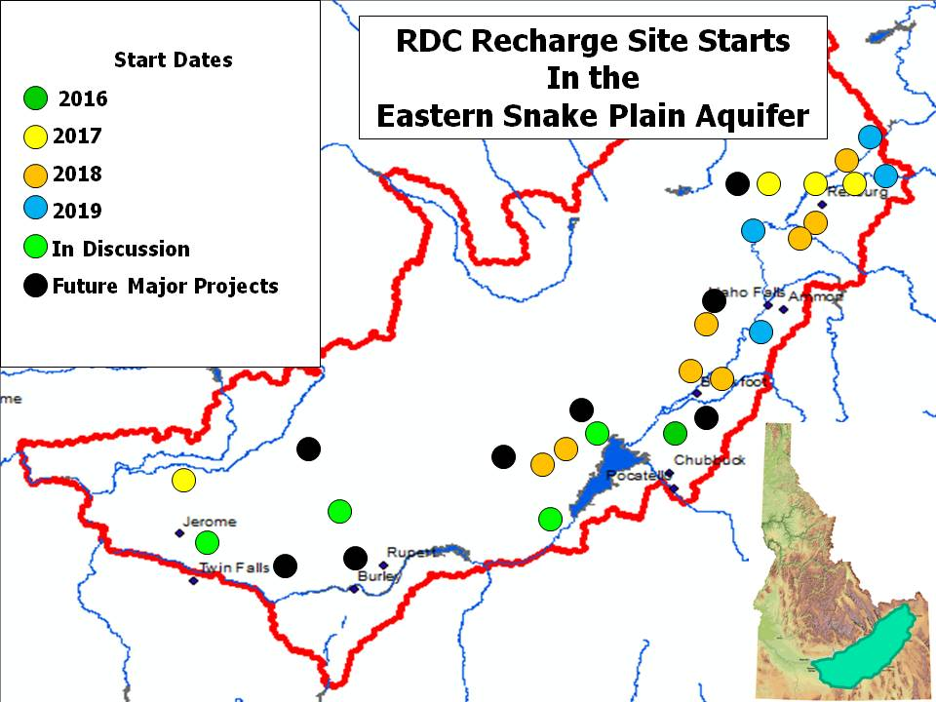
Figure 2. RDC Recharge Site Starts in the Eastern Snake Plain Aquifer

4.2 Groundwater District Applications
Idaho has established groundwater districts in locations where groundwater is now regulated or is anticipated to be regulated. These districts are located throughout eastern Idaho. As defined by the enabling statutes in Chapter 52, Title 42, Idaho Code, these districts have the power to develop mitigation solutions on behalf of their members.
In December, 2017, the Board of the American Falls Aberdeen Ground Water District presented to their general membership meeting a proposal to acquire 2,500 Class-G ARUs, if supported by the general membership. After significant discussion and debate the proposal passed unanimously pending a due diligence effort by the Board. The Board hired a water attorney to conduct a legal review of ARUs, resulting in a significant investigation of the ARU process. This review identified no reason to alter the plan for purchase. On March 14, 2018, the agreement to purchase 2,500 ARUs was signed and water has already been made available to fill the ARUs. RDC is now in discussion with other groundwater districts regarding purchase of ARUs. This technique is nicely aligned with the purposes for which the districts were formed, either on a district-wide basis or for individual water users within a district.

4.3 Tribal Factor in MAR
American Indian Reservations cover significant lands in the western Unites States. Much of this land is located in headwater areas, where opportunities exist for MAR. As an example in Idaho, RDC and the Shoshone Bannock Tribes signed a two year pilot agreement in 2016 whereby credits for MAR conducted by the Tribes would be marketed by RDC, with a sharing of revenues. This agreement resulted in recharge of 1,600 acre-feet in 2016 and 1,431 acre-feet in 2017. The pilot agreement has recently been extended with a new four year agreement between the parties. The Tribes have expressed an interest in expanding their recharge capabilities, encouraged by RDC.
RDC will work to encourage participation by tribes in other basins where IMAR is being implemented.

5.0 Data Acquisition Techniques
Real-time data acquisition enables improved water management by providing water managers with opportunities to make decisions on water use based on water supplies. For example, watering of alfalfa for a marginally profitable fourth cutting might be influenced by water availability. Historically the costs of real-time data acquisition have been high, requiring the installation of meters and on-site inspection of read-outs. Presently in the ESPA, water users are required to install meters on irrigation wells so real-time management can be made available via the transmittal and management of the data output.
Teton Technology has developed a data sending device that can transmit digital data produced by most types of flow meters, to a radio receiver located up to 35 miles (56 km) away. RDC and two groundwater districts funded the development of a cloud-based system that was developed under a contract with Teton Technology. This system was implemented in 2018 and is being tested and expanded this year to accommodate wider application in the future.
In 2017, RDC teamed with the American Falls Aberdeen Ground Water District and the Bingham Ground Water District to develop the web based portion of tracking diversions from wells and filling of ARUs. Teton Technology developed a software package that is presently in the testing phase. This software enables individuals to see their own water pumping status, and water used from their ARUs. It also enables visibility at the groundwater district level and the basin level. The software calculates assessment algorithms that include priority dates, tiered systems and recharge credits; pairing with moisture sensing technology and other agri-sensors to enhance management capabilities; and provide greater insight to farm managers and district managers.

6.0 Costs

The protocols for pricing ARUs was adapted from Reclamation’s pricing surface storage space for potential storage space holders. Because of the requisite processes involved in filling ARUs, a single designation of aquifer storage space can be problematic. Reclamation space is priced based upon the costs associated with creating space to retain water for space-holders. ARU pricing is analogous. The cost of an ARU depends on the Class designation. Surface water is moved through MAR to Class S ARUs (S connotes Surface water). This is analogous to the collection of surface storage in reservoirs before it is allocated to the various space holders. Idaho reservoirs may store water under several water rights and each water right is associated with a “Class” of space-holder. Class S ARUs are sold to entities that already have surface water supplies and MAR capability. When Class S ARUs are sold for $25/ARU it reflects the credit given for existing capacity and infrastructure. Class G ARUs are designated as a storage vehicle for groundwater users (Class “G” connotes Groundwater). Class S ARUs are made available to surface water delivery organizations like canal companies and irrigation districts and frequently include municipal providers. Class S ARUs are designed specifically for moving surface storage to aquifer storage. Because of the accounting processes employed by Water District 1 in eastern Idaho, the volume of storage diverted frequently is not known until the final accounting is completed. Similarly, surface storage that was intended to be moved to ARUs may not have actually been required because unappropriated stream flow is later deemed to have been available. A Class G ARU can be purchased by any water right holder within the basin, but until conjunctive management of groundwater and surface water is more fully established Class G ARUs will be most valuable to those with rights to pump groundwater.

Costs of making ARU storage available in a basin are largely based on the specific nature of that basin. The costs associated with gaining storage rights in the ESPA provide a known example. The initial cost is the cost of building the requisite infrastructure. In the case of IMAR it includes construction of one or more recharge sites. Once constructed there is the repayment period. The monies associated with federal reclamation projects had to be paid back over 40 years. The RDC repayment period is generally 10 to 20 years. Reservoir space must be maintained and that involves the annual payment of O & M (operation and maintenance). ARU owners pay for the operating costs of the non-profit through an annual assessment. The ARU repayment cost is in addition to the annual O & M. One consideration in the ESPA is many of the initial costs were borne by initial ARU holders for development purposes in exchange for ARUs. Other basins will benefit from the information gained in the ESPA.

Operation and Maintenance costs are shared costs. As the number of ARU owners increase there will be better economy of scale and the per ARU cost is expected to decrease. Costs to acquire Class S and Class G ARUs range from $25 US to $250 US each. The cost of a Class S ARU is ten percent of the cost of a Class G ARU. This is because owners of Class S ARUs are responsible for moving surface water into Class S ARUs. Class G ARUs are comparable to the development of new surface storage space. All but 10% of the monies paid to acquire Class G ARUs are used to expand MAR capacity. Ninety percent of the money paid to acquire Class G ARUs is deposited in a trust fund, like an endowment. The Class G ARU represents usable groundwater storage and is appropriate for any individual, municipality or groundwater district that wishes to use the water from the ARUs it owns.
7.0 Qualifying Basin
To be a candidate for implementation of RDC concepts, a basin needs the following attributes:
- Diversions from groundwater are regulated or are soon to be regulated.
- The aquifer has space to accept recharge.
- A source of water for MAR is relatively nearby and in reasonable quantity and quality for at least part of most years.
- The state or nation has a regulatory framework that accommodates the RDC concepts identified above. Our analysis suggests that most of the western United States qualify for this fourth requirement. International acceptability is currently being explored.

8.0 Potential for Implementation in other Basins
Starting in the summer of 2018, RDC has been actively seeking opportunities for implementation in other basins. Initial outreach has resulted in feedback for potential implementation in additional basins in Idaho, and in Oregon, Washington, Nevada and New Mexico. RDC anticipates the addition of other basins internationally, with RDC providing start-up assistance which will lead to long-term operations by local non-profit water delivery corporations.

9.0 Conclusion
The principals of RDC have spent many years developing the concepts and techniques described in this paper, to provide for conjunctive water management through the implementation of Incentivized Managed Aquifer Recharge. Although the patent is still pending for the concepts discussed here, the system is now operational in the Eastern Snake Plain Aquifer in Idaho. Initial steps have been implemented for starting the process in many other basins. These processes incentivize basin water management as the vector for conjunctive water management and for making water available for additional beneficial uses. The principals of RDC look forward to assisting others with implementation of these concepts.

Author Contributions: The authors wish to acknowledge the significant contributions of the full Board of
Recharge Development Corporation, who assisted in developing, refining, and implementing the concepts in this paper, including: Hal N. Anderson, Ernest M. Carlsen, Stanley M. Clark, Marc S. Elliott, Keith R Esplin, Kent W. Foster, Christopher A. Pratt, and Phillip J. Rassier.

Conflicts of Interest: The authors declare no conflict of interest.

Abbreviations
The following abbreviations are used in this manuscript:
MAR: Managed Aquifer Recharge
IMAR: Incentivized Managed Aquifer Recharge
ARU: Aquifer Recharge Unit
ESPA: Eastern Snake Plain Aquifer
ESPAR: Eastern Snake Plain Aquifer Recharge, Inc.

References
- Tuthill, D.R.; Rassier, P.J.; Anderson, H.A. Conjunctive Management in Idaho. The Water Report, 2013, Vol.108, pp. 1-11.
- Mortimer, E. Managed Aquifer Recharge: an Overview of Laws Affecting Aquifer Recharge in Several Western States. The Water Report, 2014, Vol.127, pp. 11-25.
- Mortimer, E.; Tuthill, D.R. Part II: Legal Issues in the Western US. The Water Report, 2014, Vol.129, pp. 13-22.
- Tuthill, D.R; Anderson, H.A.; Comesky, M. Managed Aquifer Recharge - Benefits of Public-Private Partnership. The Water Report, 2014, Vol.130, pp. 1-10.
- Tuthill, D.R.; Carlson, R.D. Incentivized Managed Aquifer Recharge. The Water Report, 2018, Vol.176, pp. 11-21.
- Carlson, R.D.; Tuthill, D.R. Managing Aquifers for Storage. The Water Report, 2018, Vol.177, pp. 1-9.

